How to Deploy ARM Templates

In the following videos, I download the ARM templates to my local machine and they include scripts for Powershell, Ruby, Bash, and C#. Microsoft has since removed those files from the download.

So if you need to deploy ARM templates from your local machine (or cloud shell), I've uploaded the scripts here for you to download and use.

<https://github.com/gottagetgit/ARMDeploy>

* First delete resources from the resource group except virtual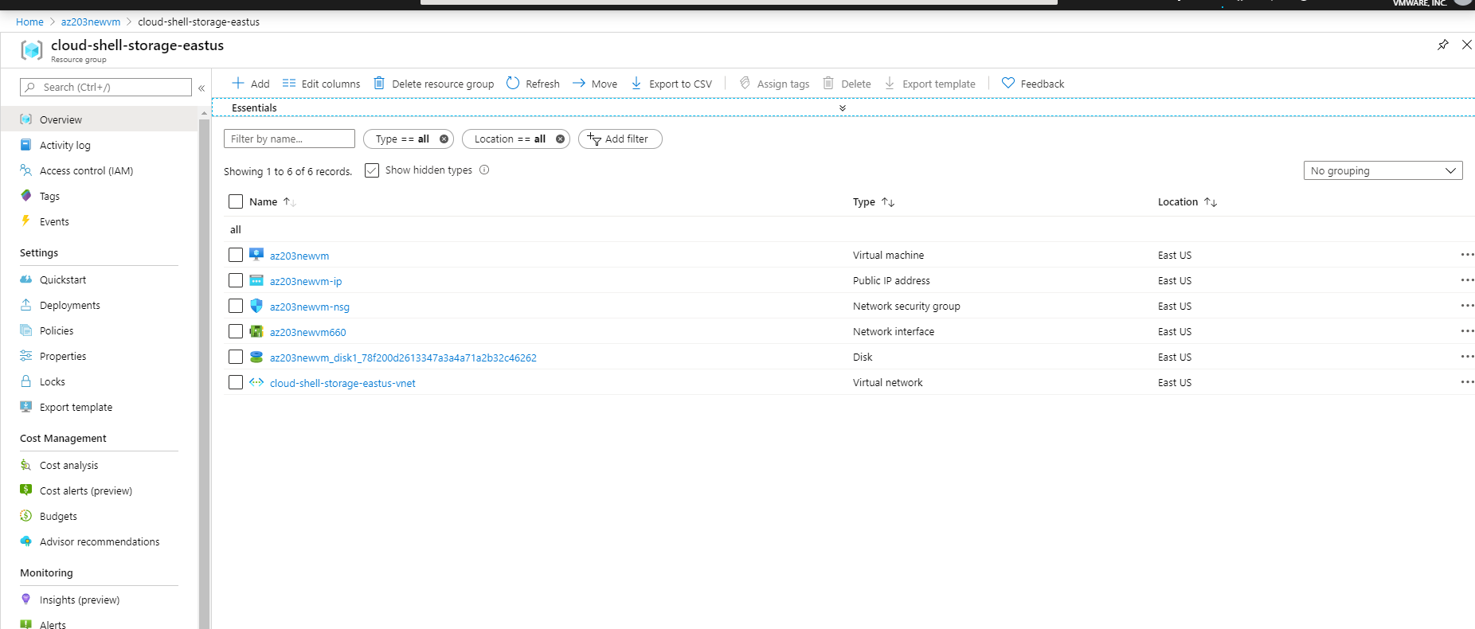
* Deletion is required because we want to create and automated creation of VM